Comparative Analysis
- Paragraph without coherence:
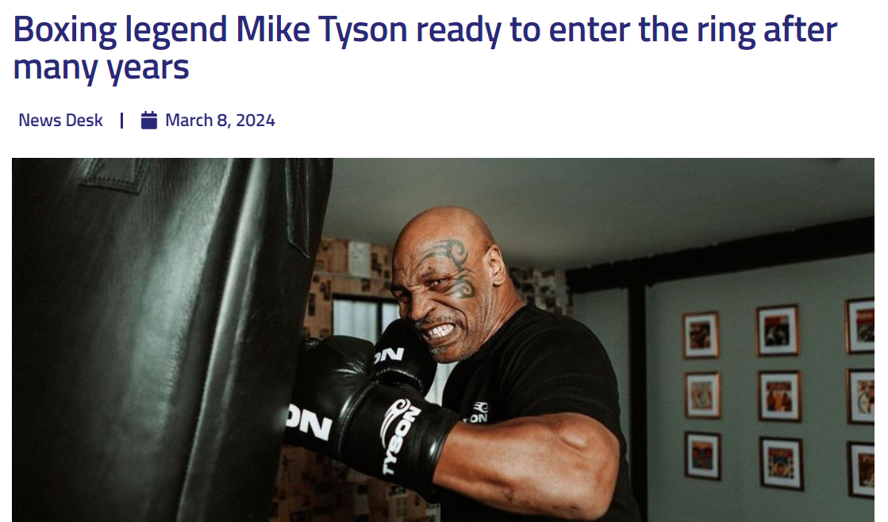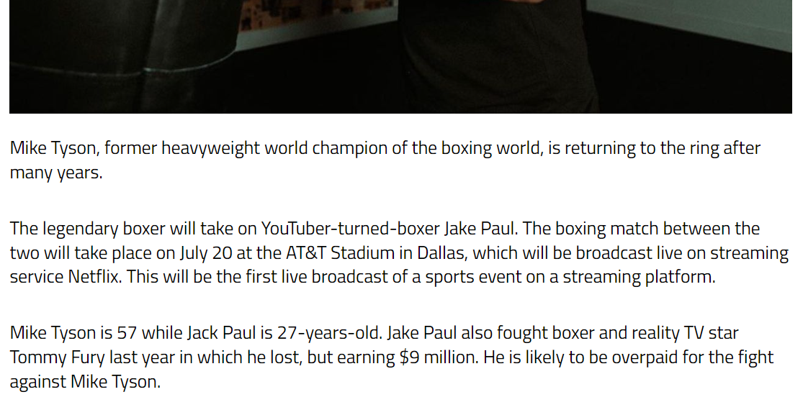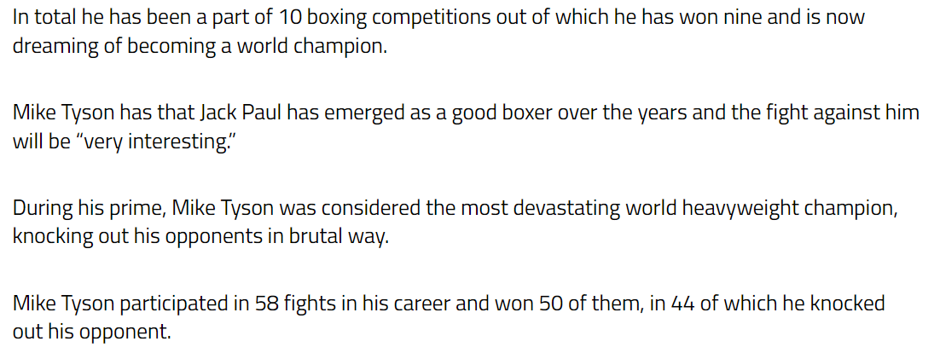
- Paragraph with coherence:
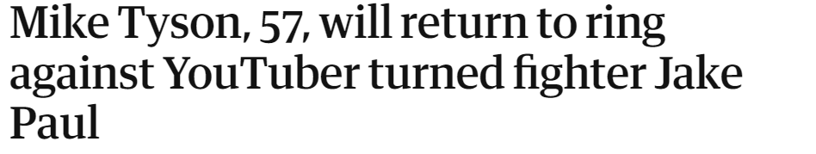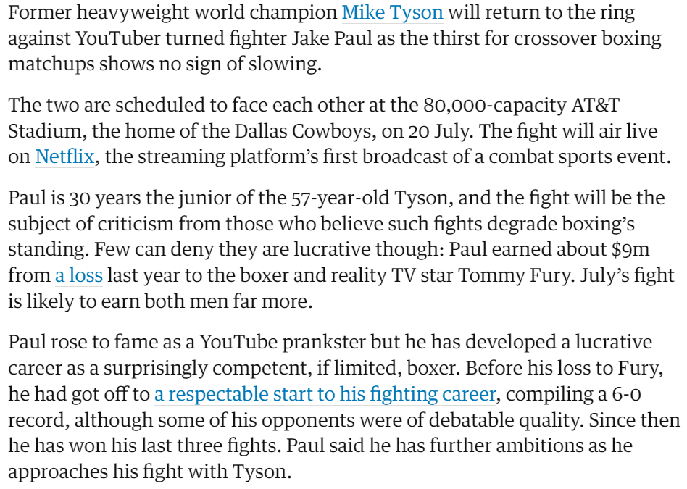
Main Idea:
The main idea of both the paragraphs is to break the news of the returning of the former heavy weight world champion of the boxing world, after many years. He is going to have a face-to-face fight with Jake Paul. The world is thrilled to see the two personalities face each other.
Supporting Details:
In both paragraphs, the supporting details give more information about the two boxers and give some information about their careers.
Structure:
Both the paragraphs are well structured featuring the topic sentence followed by main sentence supporting the topic sentence. After that, supporting details are given about Paul first and then Mike.
Use of Transitions:
In the first paragraph, some transitions have been used to create a flow of ideas. Some of them are “while” “in which”, “but”, “In total”, “out of which”, “During his prime”.
In the second paragraph, some of the transitions used are “as the thirst for”, “but”, “Before his loss”, “although”, “Since then”, “he approaches”.
Strengths and weaknesses:
The first paragraph lacks coherence due to the excessive use of pronouns. As stated in the text, “Jake Paul also … in which he lost, but earning $9 million. He is likely … Tyson. In total he has …of which he has won nine and …” (“Boxing legend Mike Tyson ready to enter the ring after many years”)
In the first line, the pronoun “he” is used for Jake Paul, but it seems that it has been used for Tomm Fury because he was most recently mentioned. Similarly, “He” is used afterwards creating an ambiguity among the readers.
Whereas the second paragraph possesses the quality of coherence. As stated, “Few can … though: Paul earned about $9m …
Paul rose to fame as …won his last three fights. Paul said he has further ambitions as he approaches his fight with Tyson.” (“Mike Tyson, 57, will return to ring against YouTuber turned fighter Jake Paul”)
As we can see here, the proper noun “Paul” has been used at places where confusion is possible, creating a sense of coherence and a flow among the paragraphs.

Reflection:
As we observed from the comparison of the above paragraphs, unity and coherence has a significant importance in writing content. Unity provides the linkage of ideas and connects them creating a sense of ideas throughout the whole paragraph. On the other hand, coherence creates a flow among the sentences of a paragraph, making it easier to read and understand for the reader. So, we can apply unity in our writing by adding supporting detail that is related to the topic sentence. Whereas, coherence can be added by usage of key nouns, pronouns where needed, transition signals to link ideas smoothly and last but not the least, arranging our ideas in a chronological sequence.

